CSCI2730 project
The NFT Marketplace Report
By: He Ching Kui & Wong Wang Ming

Content page
Introduction 3
Implementation 3
Aims 3
Target users 3
Functions 3
Get Started 4
Install Foundry and Next.Js 4
Build Local Project 4
File Structure 5
Function Flow Diagram (List and Auction) 5
How to Use 6
Create NFT 6
View NFT 7
List NFT 8
Manage NFT 9
NFT transaction 9
Bidding 10
Conculsion 13

Introduction

Implementation
The largest current NFT exchange system OpenSea provided NFT create and trade services for users. However, OpenSea charged every transaction 1% platform fee, which may discourage active participation and reduce the willingness of users to exchange NFTs. To enhance the development of NFT, we created a new NFT standard and a marketplace with no fee charged.

Aims
The website aims to eliminates transaction fees, thereby lowering barriers for creators and collectors, and encouraging more frequent and accessible NFT exchanges.

Target users
The target users of the website are NFT creators (both image and video creator) and buyers. The website is user-friendly for creators, which they can create NFT easily and sell them without platform fee. The buyers can buy NFT with lower cost.

Functions
The BNFT standard implemented in this project provides the essential functions of mint, burn, list, buy, auction, and bid. These functions are integrated into the website to deliver a complete and seamless NFT exchange experience.

Get Started
You need to follow these instructions only if you want to open the website yourself. As we host the website locally as a demo, to install the environment might be hard. Therefore, in How to use, we provide screenshots to show how to use all functions. (Also presented in presentation video)

Install Foundry and Next.Js
Noted that we used Foundry 0.3.0
Foundry Document: foundry - Ethereum Development Framework
Next.Js Document: Getting Started: Installation | Next.js

Build Local Project
These steps are used to install dependencies for frontend, they are completely formed by our trial. Therefore, you may use some faster way if you know.

Step 1: Create a new Next.js app, follow instructions in Next.Js Document and video [1.20 to1.48]
Video link: The video
Step 2: Copy the dependencies in /node_modules to our project /web/node_modules (create the folder node_modules)
Step 3: Install ethers 5.7.0 [npm install ethers@5.7.0]

Step to run the blockchain and web
1. code: anvil
2. copy private keys and address to /contracts/.env
3. go under contract/
4. code: source .env
5. code: forge create --broadcast --rpc-url http://127.0.0.1:8545 --private-key ${user1private_key} src/BasicNFT.sol:BasicNFT
6. copy the "deployed to" address to /web/app/utils.js : ContractAddress
7. copy /contracts/out/BasicNFT.sol/BasicNFT.json to /web
8. go under web/
9. code: npm run dev
10. open the website
11. connect to the network in metamask

File Structure
The structure should be clearly shown in GitHub. Here is to state where is the contract and scripts for web that we did. The smart contract is in contracts/src/BasicNFT.sol, the test script is in contracts/test/BasicNFTTest.sol. The frontend scripts are in web/app.

Function Flow Diagram (List and Auction)
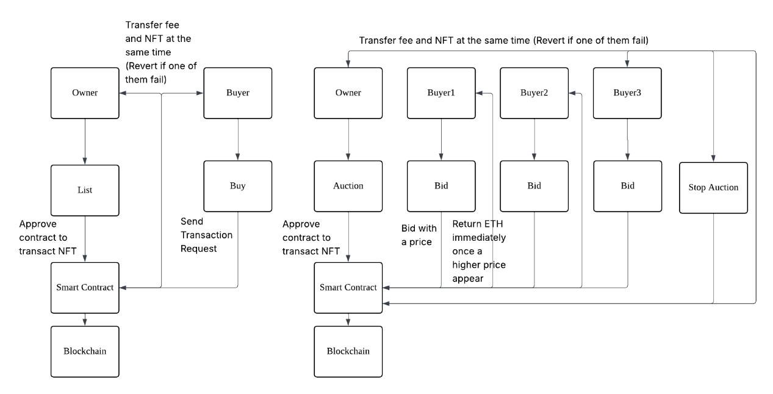

How to Use

Create NFT
Select the media type that you want to create at the pulldown menu(image/video).
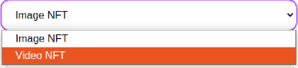
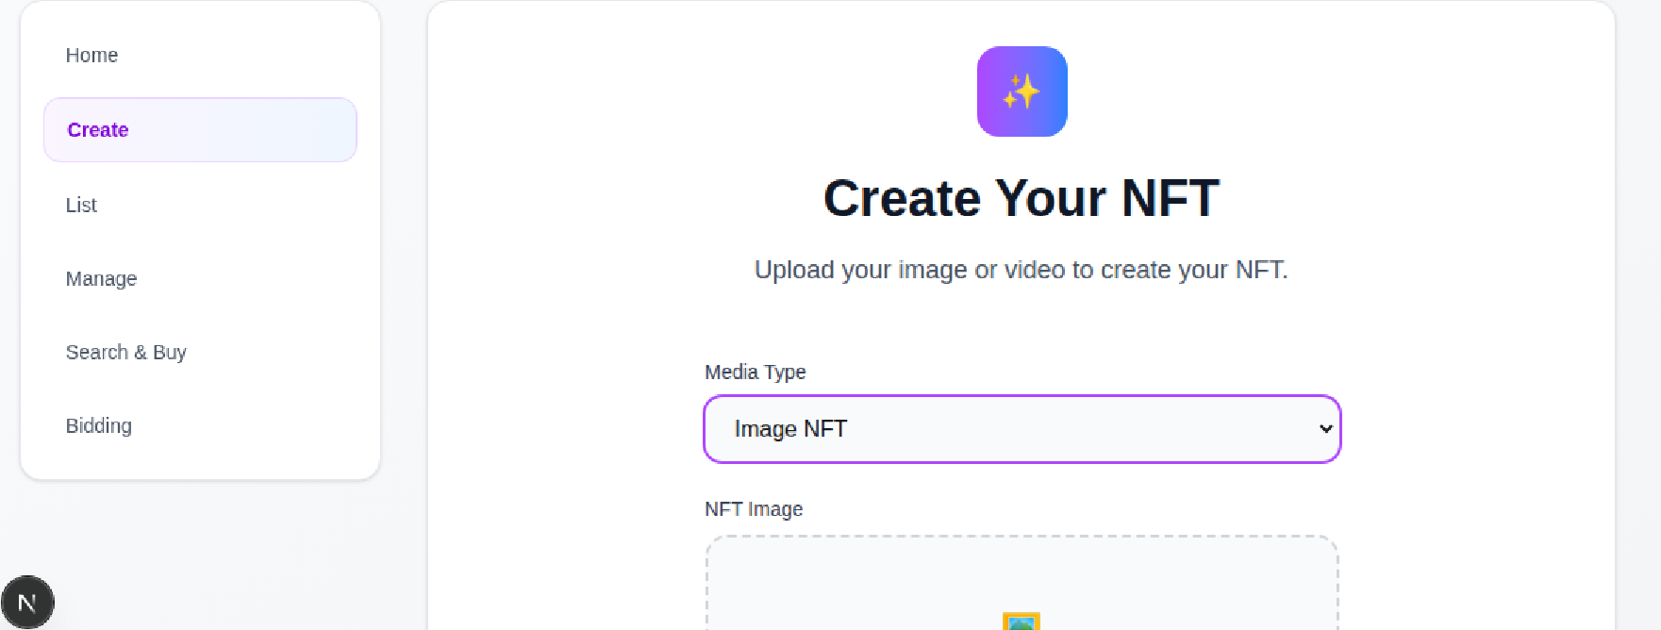

For example, select “Image NFT” and upload a heart.png to be the NFT.
Click the upload file area and select the heart file.
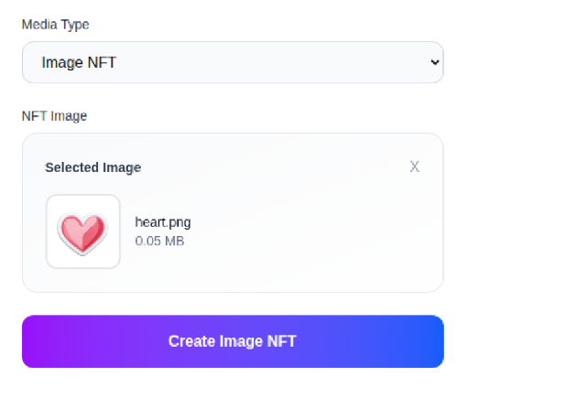
Click “Create Image NFT”.

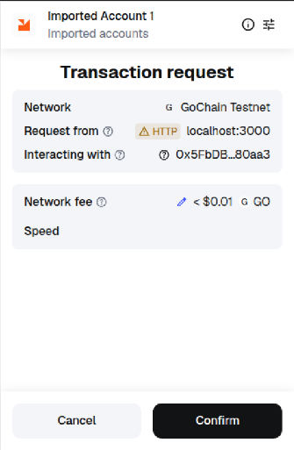
The MetaMask account will pop up a window, click Confirm.
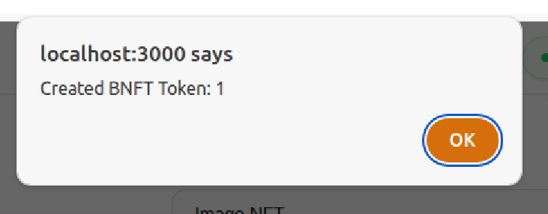
After the transaction is confirmed, a pop-up window will tell you the token ID.
Your NFT has been successfully created!!

View NFT
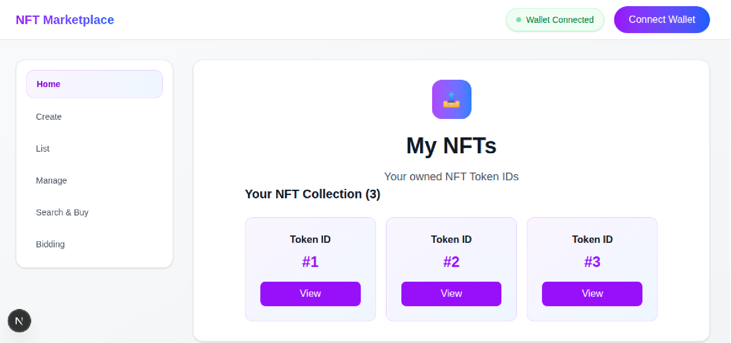
Back to the Home page, you can view your NFT collections that you created or bought.

Click “View” under the token ID #1.
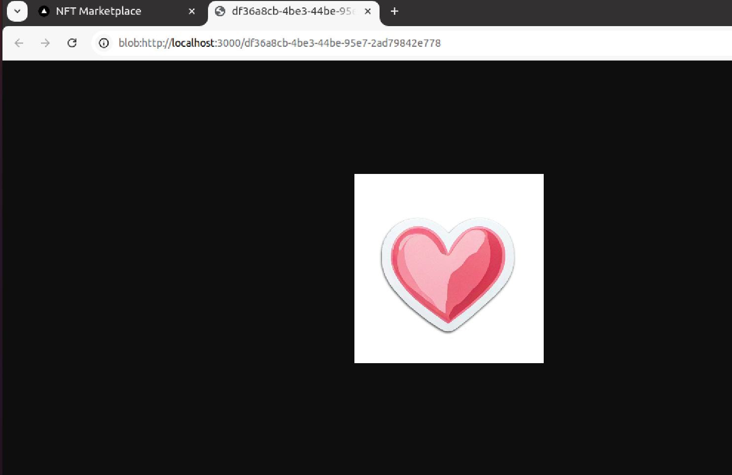
A new tab will show your NFT image/video.

List NFT
Go to the List page, input the Token ID and the Listing Price(ETH) to List.
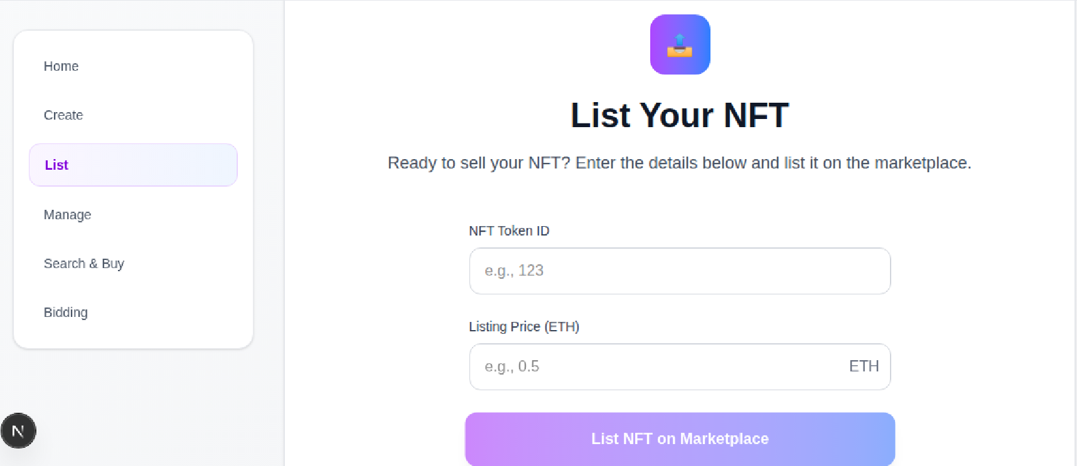
Input the token ID of our heart NFT and set the listing price to be 10ETH.
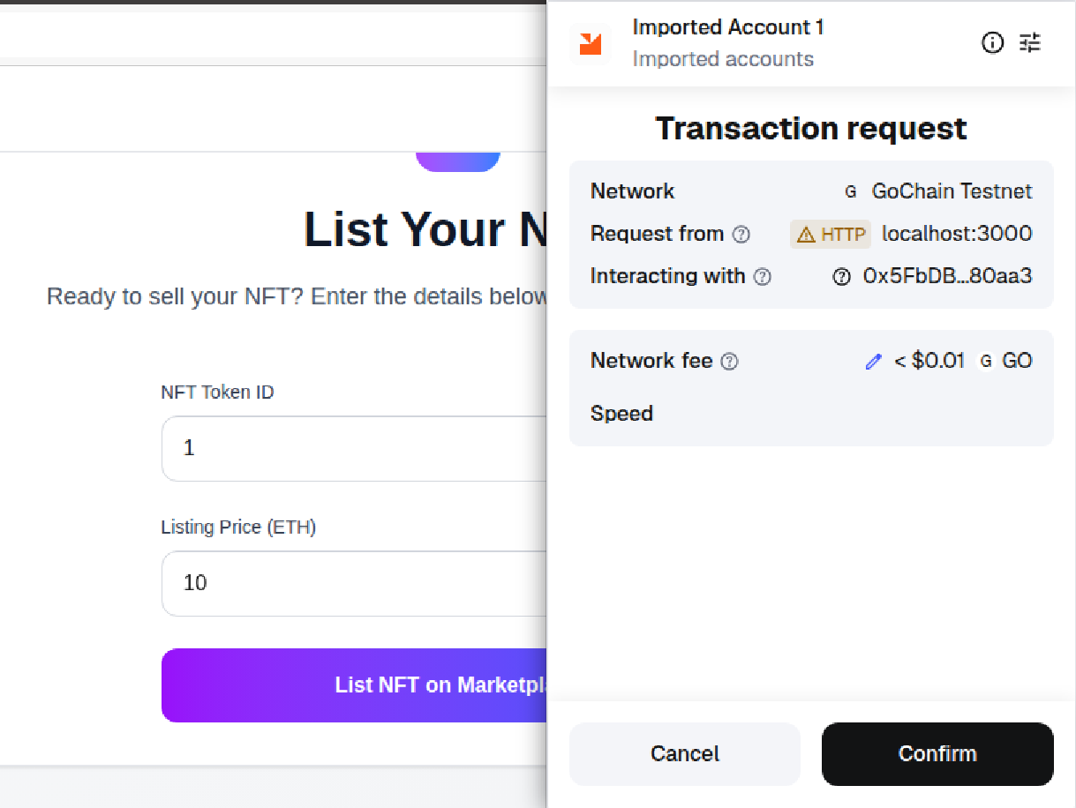
Click List NFT on Marketplace. Click Confirm.
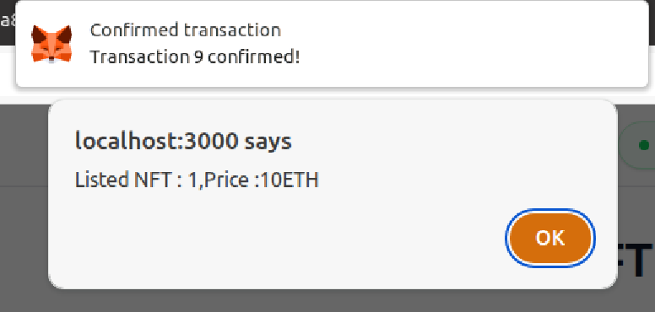
Your NFT has been successfully listed!!

Manage NFT
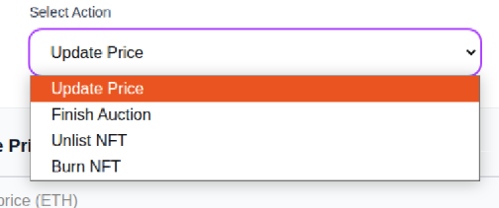
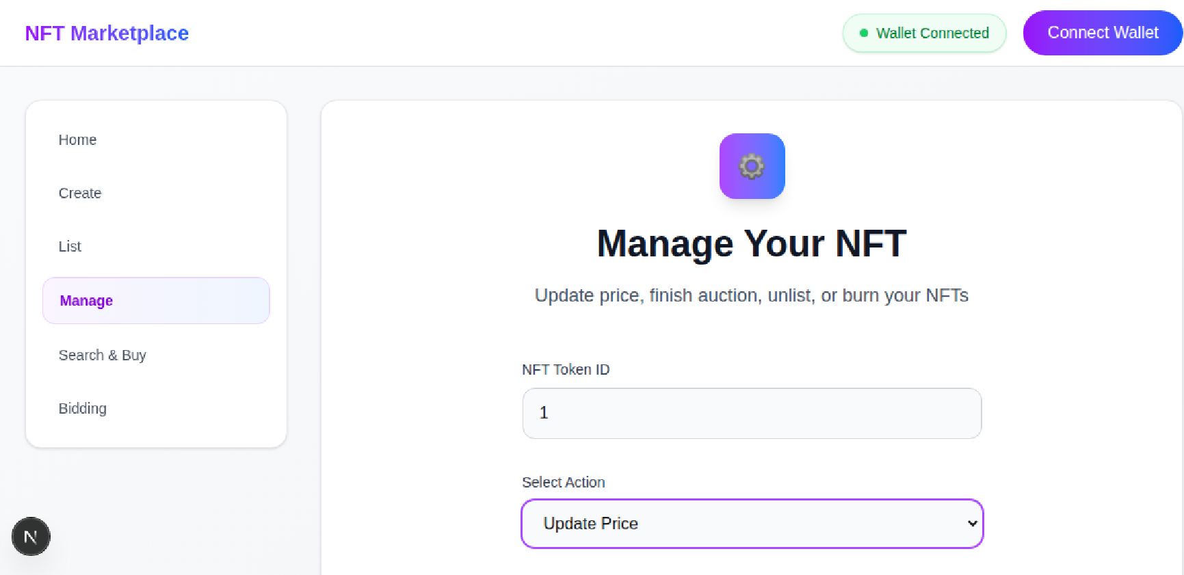
At the manage page, you can do these four types of actions, including update price, finish auction, unlist and burn NFT.

NFT transaction
For the bidding function, we need 2 accounts.

Account1: 0xf39fd6e51aad88f6f4ce6ab8827279cfffb92266

Account2: 0x70997970c51812dc3a010c7d01b50e0d17dc79c8

Account3: 0x3c44cdddb6a900fa2b585dd299e03d12fa4293bc (for next part)

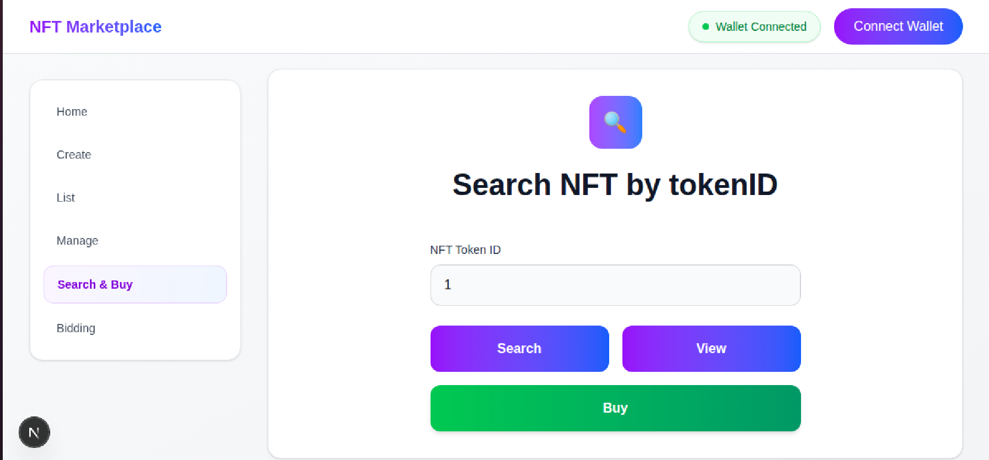
Connect to account2, go to Search & Buy page.
Input the NFT token ID and click Search.
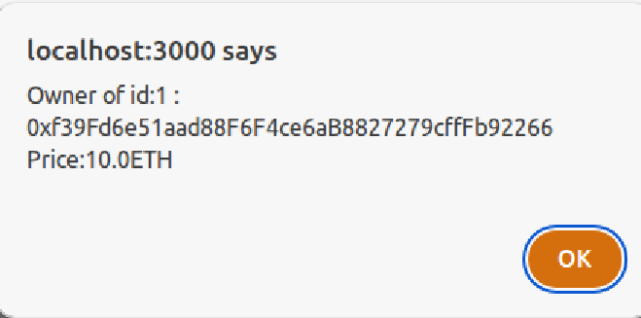
The pop-up window will show the owner of the NFT and the price.

Click View. The NFT will be shown on a new tab same as previous.

Click Buy. Click Confirm.
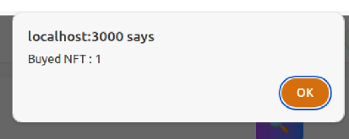
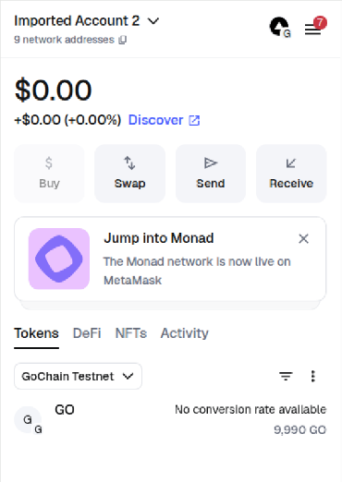
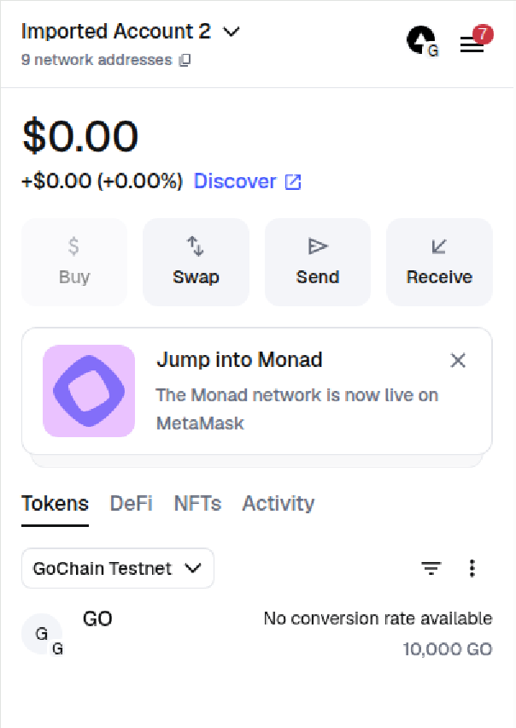
After transaction, the balance of account2 will decrease by 10 units of token.

Call the Search function again, the owner of the NFT with token ID 1 will have changed to account2.
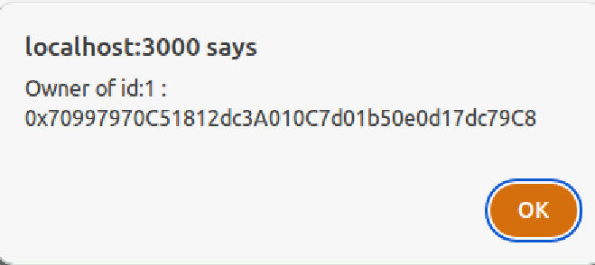

Bidding
For the bidding function, we need 3 accounts.
The NFT owner is account 2, and we will start the bidding with account 2.
Go to the Bidding page. Click Start Bidding.
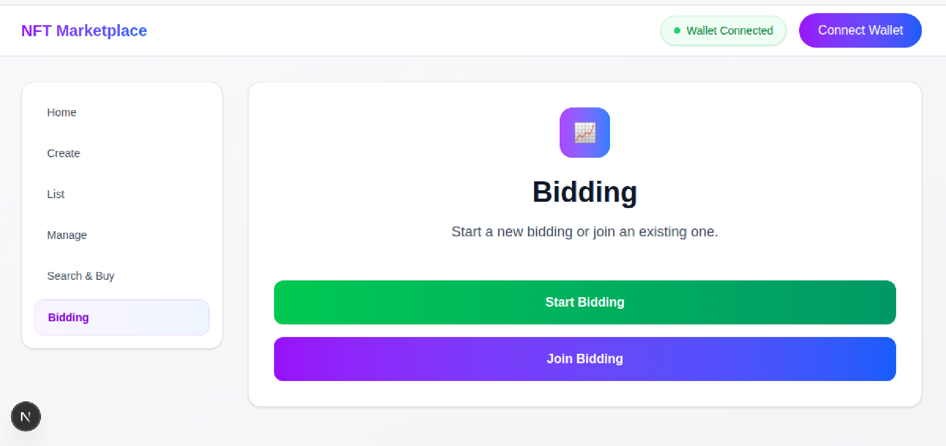

Input the NFT token ID and set the Base Price at 20ETH.
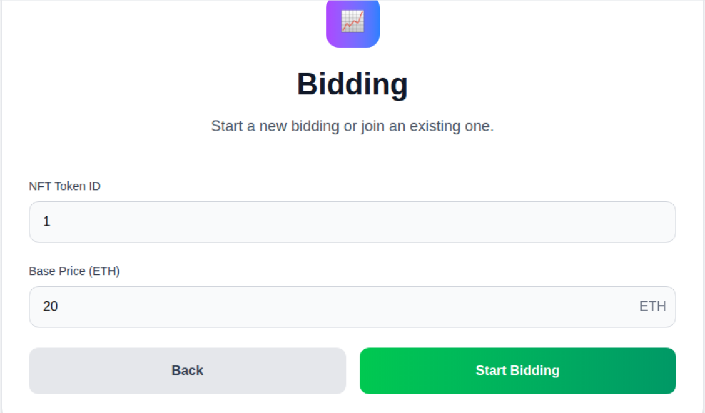
Click Start Bidding. Click Confirm.
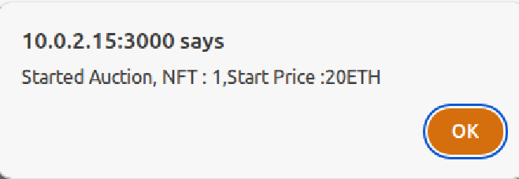
Now connect to account 1. Click join Bidding.
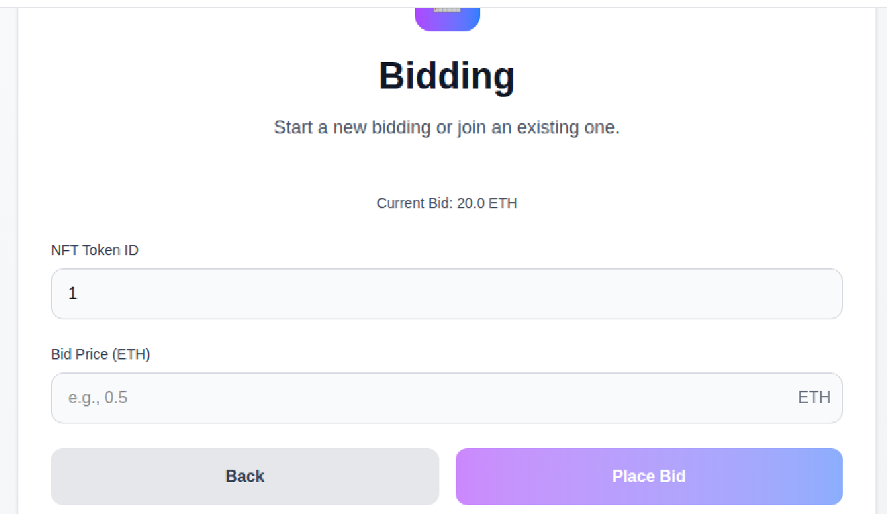
After inputting the token ID, the current bid price is shown.

Set 25 as the bid price. Click Place Bid. Click Confirm.
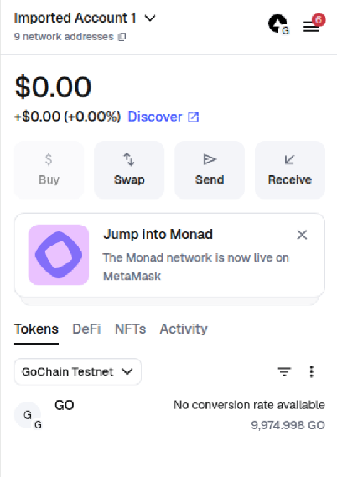
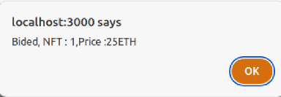
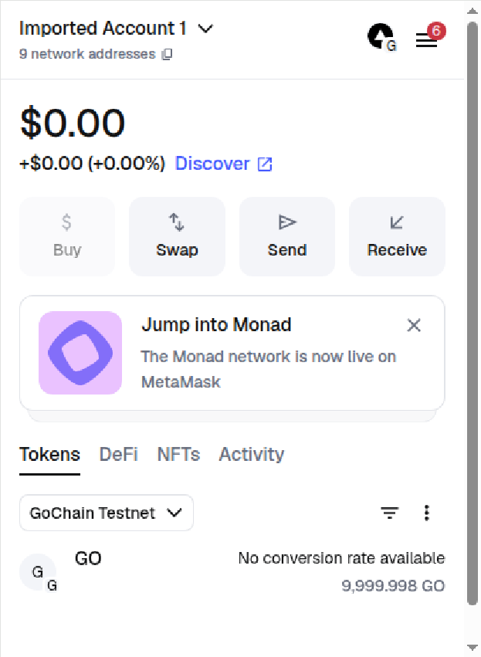
The balance of account 1 will be decreased by 25.

Connect to account 3 and join bidding.
Set 30 as the bid price. Click Place Bid. Click Confirm. As this moment, the bid price of account 3 is the highest, so the 25 ETH will be returned to account 1.

The current bid price will be updated to 30 ETH.
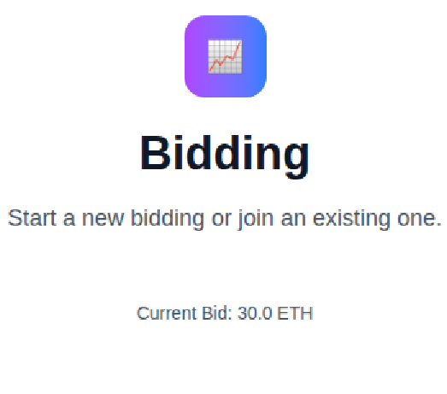

Back to account2, go to “Manage” and “Finish Auction” field, input the tokenID 1 and click Finish Auction. Click Confirm.

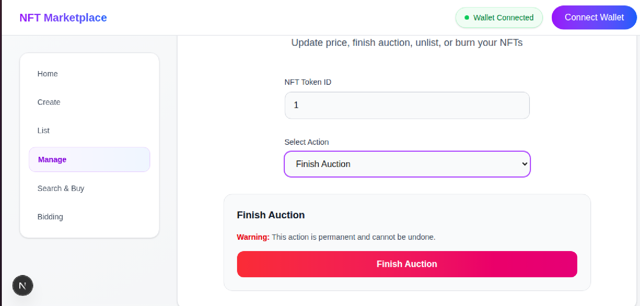

After that, the 30 units of token will be transferred to account 2.
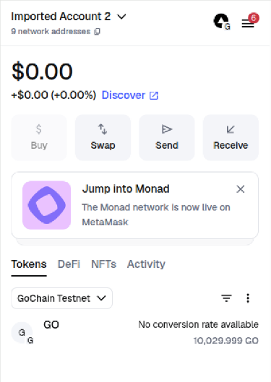
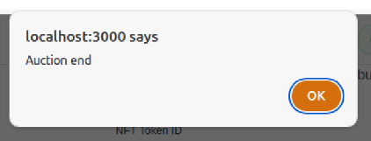
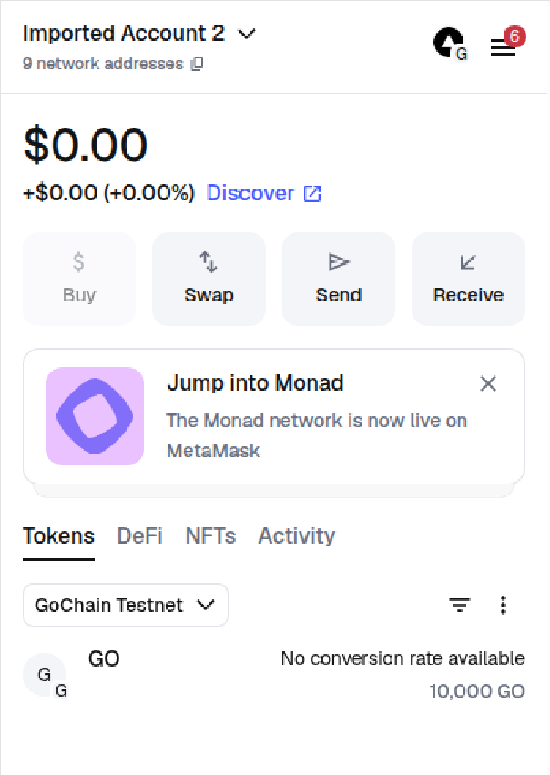

And the owner of the NFT will be account 3.
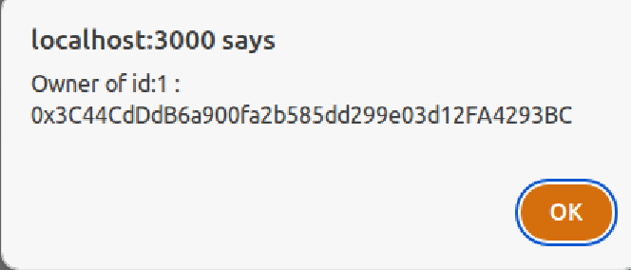

Conculsion
In summary, we have implemented a NFT marketplace demo to demonstrate all basic NFT activity. Having this zero platform fee website as a start, NFT exchange might be encouraged, and improve NFT market in the future.

